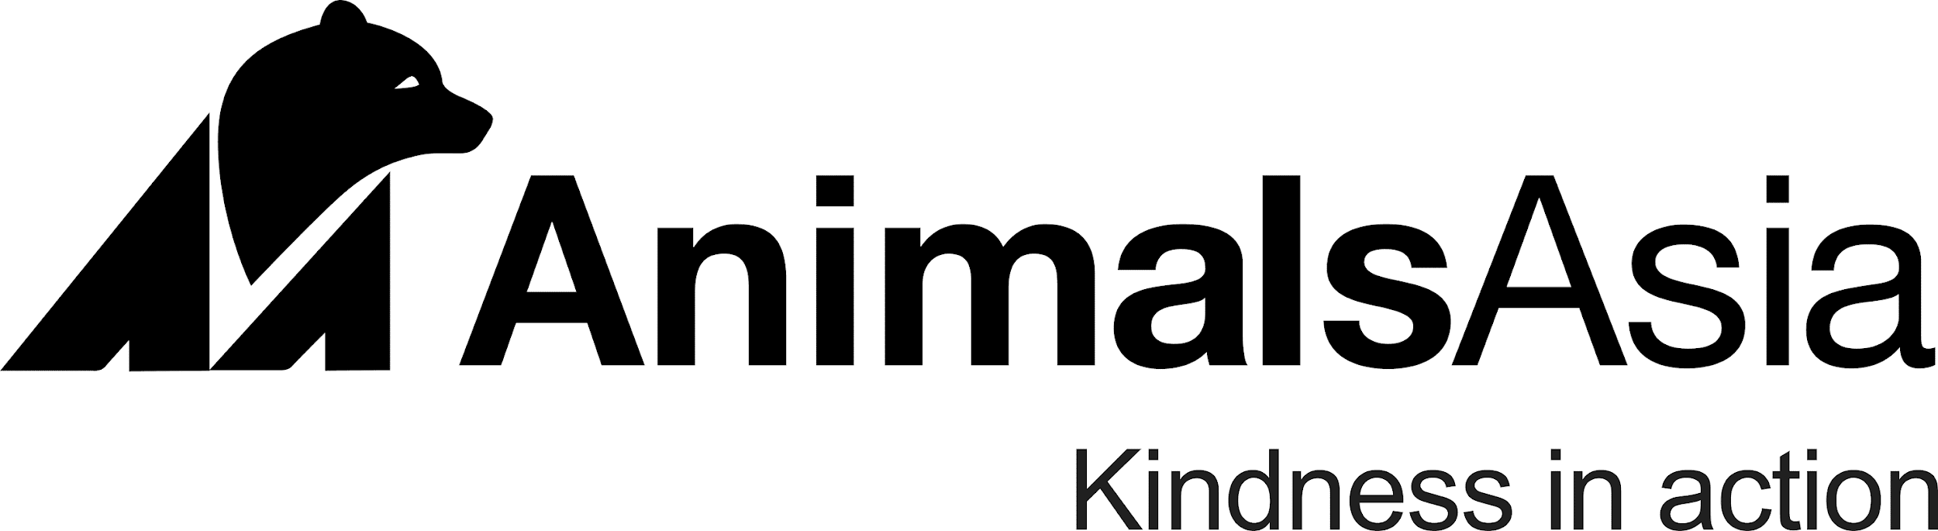
Project Coordinator (Government Rescue Centre Support) Recruitment 2025
Animals Asia, an international animal welfare charity, is dedicated to ending the suffering of all animals across Asia. We promote compassion and respect for all animals and work to bring about long-term, sustainable change. We are currently seeking a dedicated and motivated Project Coordinator (Government Rescue Centre Support) to join our team, based in Dak Lak, Vietnam.
Position Details:
Position: Project Coordinator
Location: Dak Lak, Viet Nam
Type: Full-time, five (5) days per week
Term: One year, including an initial two-month probationary period
The role: The Project Coordinator is responsible for coordinating and implementing Animals Asia’s support projects for government rescue centres across Vietnam. The role ensures that project activities are delivered effectively, align with Animals Asia’s animal welfare standards, and meet donor and organizational commitments. The Project Coordinator acts as the key liaison between the Captive Wildlife (CW) team, government partners, and the Veterinary and Behavioural Husbandry Services (VBHS) team—translating technical recommendations into practical, on-site implementation and ensuring consistent progress and communication
- Key Responsibilities:
Plan, coordinate, and oversee the implementation of project activities across assigned rescue centres.
- Manage project logistics, procurement, and financial documentation in compliance with AAF and donor requirements.
- Coordinate with internal technical teams (VBHS) to ensure welfare and husbandry practices meet AAF standards.
- Support infrastructure improvements, equipment supply, and capacity-building for rescue centre staff and authorities.
- Maintain strong partnerships with government counterparts and local authorities.
- Monitor project progress, collect data, and prepare reports for internal and donor use.
- Contribute to communication materials highlighting AAF’s support and success stories. Ensure compliance with AAF’s administrative, financial, and safety procedures.

Requirements:
- Education: University degree in biology, environmental science, animal science, or a related field (postgraduate qualification in project management, wildlife conservation, or NGO management is an advantage).
- Experience: At least 5 years of experience in project coordination or management, preferably in animal welfare, conservation, or with government agencies/provincial departments.
- Skills: Strong coordination, communication, and organizational skills; ability to manage multiple priorities and meet deadlines; good problem-solving and reporting abilities.
- Knowledge: Understanding of Vietnam’s wildlife management and government rescue centre operations; familiarity with procurement, financial procedures, and project reporting.
- Language: Fluency in English (Vietnamese is an advantage).
- Personal attributes: Proactive, collaborative, and able to work independently or in cross-functional teams.
How to Apply:
Please send your cover letter and CV (stating the applied position) by click the link
In your cover letter, please clearly state:
- The position you are applying for:
- Your expected salary.
Only shortlisted candidates will be notified for interviews, the interview will be conducted in English. Closing date for application is 10th November 2025.
To find out more: www.animalsasia.org
Animals Asia values candidates with different backgrounds, experiences, and perspectives. We welcome applicants of every ethnicity, age, gender identity and expression, sexual orientation, religion, national origin, socioeconomic status, disability, or veteran status. We are committed to building an organization that creates an inclusive environment for all.
Using AI During Interviews:
Animals Asia is committed to ensuring a fair and authentic interview process. The use of artificial intelligence (AI) tools, including but not limited to real-time transcription, automated response generation or assistance in formulating interview answers, is strictly prohibited during any stage of the interview process.
We will take a candidate's agreement to participate in an interview with us as confirmation that they will not use AI tools in any form during the conversation. If it is discovered or reasonably suspected that AI has been used, the interview will be terminated immediately, and the candidate will no longer be considered for the role.
We appreciate your understanding and adherence to this policy, which is in place to maintain the integrity, professionalism and reliability of our recruitment procedures.

