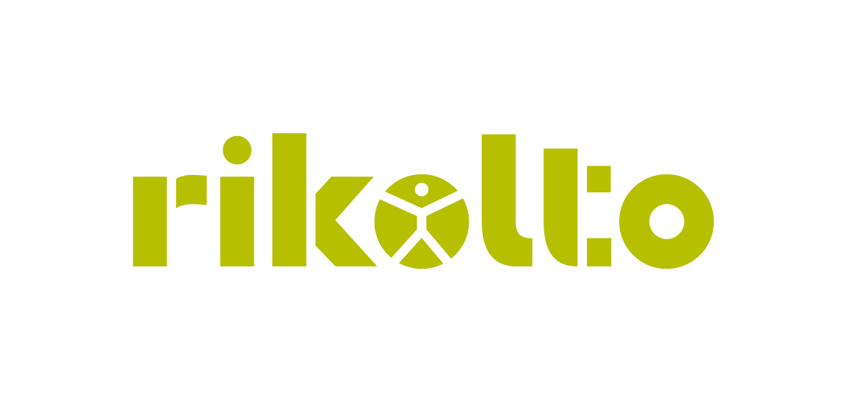

**JOB VACANCY ANNOUNCEMENT**

**Position: Project Accountant**

**Duty station: Hanoi, Vietnam**

**Background:**

Rikolto is an international NGO with over 50 years of experience partnering with farmer organizations and food chain actors across Africa, Asia, Europe, and Latin America. Rikolto operates programmes in 18 countries worldwide through 5 regional offices.

Rikolto envisions a world with a sustainable income for farmers and nutritious, affordable food for everyone. We reach our goals by building bridges between smallholder farmer organizations, companies, authorities, and other actors across rural and urban areas. Together, we create innovative ways of accessing, distributing, and producing nutritious, quality food so no one is left behind.

Rikolto in Southeast Asia (SEA) operates in Vietnam, with an office based in Hanoi. To support the implementation of our **Rice Project in the Mekong Delta region**, we are seeking to recruit a qualified Vietnamese professional for the position of **Project Accountant**, based in Hanoi.

**Job Overview:** The Project Accountant, under the supervision of the Head of Operations, will be responsible for performing day-to-day financial transactions related to the project, updating records in the bookkeeping system, and ensuring all supporting documents comply with Rikolto’s rules and regulations. Additionally, this position will be responsible for monitoring the project budget, preparing accurate financial reports, and ensuring proper filing of all financial documents.

**Job size**: Full-time (1-year contract with the possibility of extension)

**Expected starting date**: As soon as possible.

**Key responsibilities:**

* Maintain accurate bookkeeping and review financial documents related to the Rice project, ensuring compliance with Rikolto’s financial policies.
* Support budget planning and monitoring in collaboration with the Project team.
* Review and consolidate monthly financial reports from partners and provide feedback to ensure accuracy and alignment with approved budgets.
* Assist in preparing financial reports for both internal use and donor reporting.
* Provide financial guidance and support to project teams and partners, including through field visits when needed.
* Ensure proper filing and documentation of all project financial records and coordinate with the Finance staff on related matters.

**Basic Requirements:**

* Bachelor’s degree in Finance, Accounting, Commerce, or a related field; professional accounting qualifications are an advantage.
* Minimum of 2 years’ experience in finance and accounting, preferably within international development or donor-funded projects.
* Solid knowledge of accounting principles, budgeting, and financial reporting, with familiarity with Vietnamese financial regulations.
* Proficiency in Microsoft Office (especially Excel); experience with financial/accounting software is a plus.
* Strong attention to detail, with good organizational and time management skills; able to manage multiple tasks and meet deadlines.
* Excellent communication skills and ability to work independently and collaboratively, while maintaining integrity and confidentiality.

For a detailed list of responsibilities, qualifications, and requirements for the role, please refer to the **Job Description** on Rikolto Vietnam’s website at: <https://southeastasia.rikolto.org/job-vacancies/project-accountant>

**How to apply**

Interested candidates are invited to submit a motivation letter and an up-to-date curriculum vitae (CV), using the subject line: ***“Project Accountant – [Your Name]”*** to the following email address:

**Email**: [vietnam@rikolto.org](mailto:vietnam@rikolto.org)

The deadline for applications is **20 Sep 2025**.

*Applications will be reviewed on a rolling basis, so early submission is strongly encouraged.*

We appreciate all applications; however, only shortlisted candidates will be contacted for an interview.