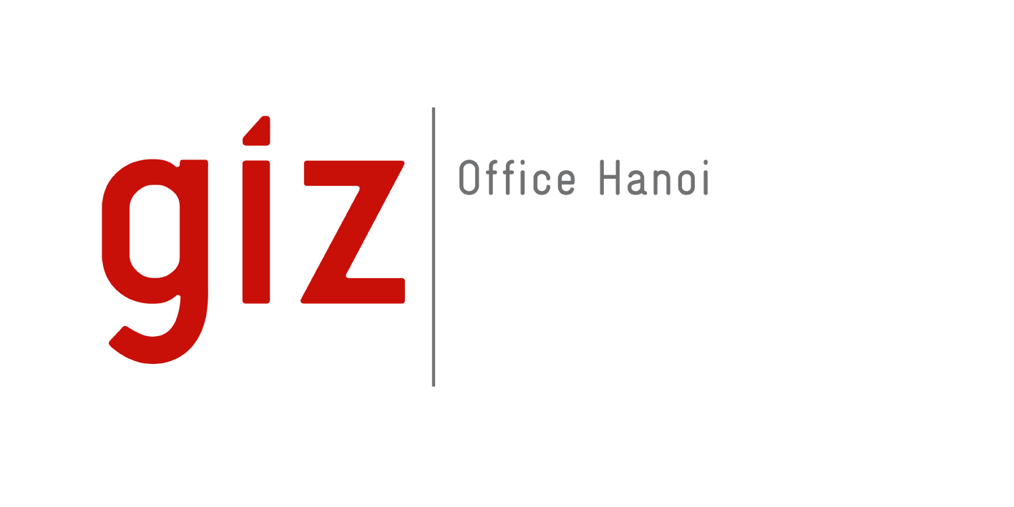 |  | HR Service Request Form

Project/Program: International Hydrogen Ramp-Up Programme (H2Uppp), 50% and Energy Partnership Project (EP), 50%
Project Number (12-digit PN): 23.9007.8-020.00 (H2Uppp) 23.9259.5-007.00 (EP)
% output distribution according to KOMP if any
O1 | O2 | O3 | O4 | O5

I. For recruitment of new national staff:
Job title: PR & Communication Specialist

Contract duration: 1.3.2025 – 31.12.2025

Officer responsible for contracts and cooperation (DV: Durchführungsverantwortlicher): Markus Bissel
Name & position of the direct supervisor: Markus Bissel
Job band/ sub-band: 1 2 3 4.1 4.2 5
Telephone allowance (VND 500,000/month gross): Yes No
Other allowances (if any):
Document attached:
Job description Profile requirements

II. For Contract prolongation and amendment (if any):
Name of the national staff (NMA):
Current position of NMA:
Name & position of the current direct supervisor:
Contract prolongation until:
Other amendments (if any):
Effective date of the amendment:
Document attached:
Justification and approval for the amendment
 | Prepared by |  | Approved by  (AV or an authorized person) | Finalized by  (HR person)
Date | 14.1.2025 |  | 14.1.2025
Signature  (if by email, please type name & attach the email) | Markus Bissel  Project Director, EP/H2Uppp, OE A200 |  | Markus Bissel  Project Director, EP/H2Uppp, OE A200

