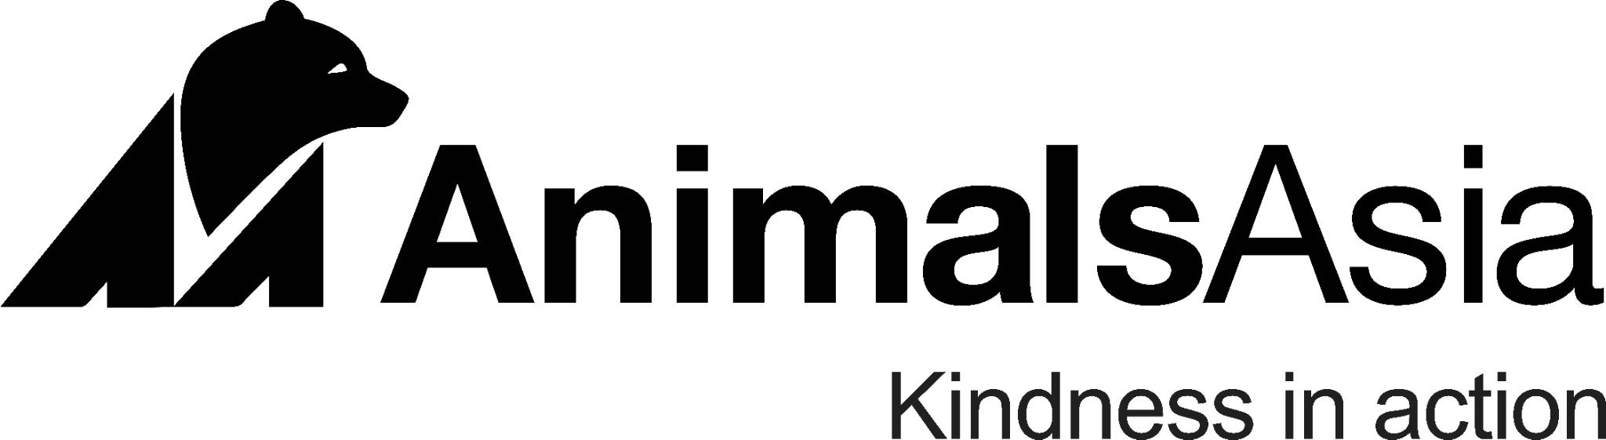

**Translator (English/Vietnamese)**

Animals Asia is recruiting a full-time Vietnamese national English/Vietnamese translator. Animals Asia is an international animal welfare charity founded by Dr. Jill Robinson MBE in 1998. Animals Asia operates the only sanctuary accredited by the Global Federation of Animal Sanctuaries in Vietnam, housing more than 190 rescued Asiatic black bears and Malayan sun bears. Our mission is to end the farming of bears for bile and provide lifelong care and sanctuary for rescued bears. This position will be based at the Vietnam Bear Rescue Centre in Tam Dao National Park, Vinh Phuc Province.

You have excellent interpersonal skills and are fluent in English and Vietnamese. You are confident interacting with a range of people, whether they are major donors, supporters, authorities, or officials. You enjoy language and are equally at home indoors in front of a computer, our working outdoors (often near animals) helping people to communicate.

This is an incredible opportunity to join a dedicated, high-functioning, and cohesive team which is Kindness in Action.

**Location:** Tam Dao National Park, Vinh Phuc Province

**Type:** Full-time

**Term:** Two-year contract, extendable based on performance with initial 2-month probationary period.

**Salary:** Grade 3.4 , allowance + free accommodation, other benefits.

**Responsibilities:**

* Interpret (English into Vietnamese and vice versa) during work activities, meetings, workshops or field trips.
* Translation of work materials from English to Vietnamese and vice versa.
* Provide administrative support when required.
* Attend staff meetings to translate and take minutes as required.
* Assist in the development and maintenance of effective working relationships between staff from Animals Asia and both internal and external partners.

**Requirements:**

* University graduate (preferred English language major) with at least two years of relevant work experience in an English-speaking environment. Recent graduates with exceptional skills will be considered.
* Excellent communication skills and the ability to live and work closely with the rest of the team comprising both expatriate and local staff.
* Cultural sensitivity and awareness.
* Familiar with the use of computer programs such as Microsoft Word, Microsoft Excel, and email.
* Able to live in Tam Dao National Park, Vinh Phuc Province.
* Able to work in a flexible and timely manner, with availability outside of standard working hours and go on business trips when required.

**To apply**

**Please send a letter detailing your suitability for this role (in English, please) and your C.V. to** [**nhoang@animalsasia.org**](mailto:nhoang@animalsasia.org)

**Applications close Monday, 10 Feb, 2025.**

**Interviews for selected candidates might be conducted by Skype/Zoom (please ensure you have a working webcam and microphone).**

**Personal data collected will be treated in strict confidence and used solely for recruitment purposes and will be destroyed after 6 months.**