Office Equipment Disposal - Bidding Opportunity
We would like to announce that The Asia Foundation in Vietnam (TAF) is in the process of disposing of old laptop and are inviting interested parties to place their bids. Below is a list of items available:

Items for Disposal:
- Laptop: 01
Details: MacBook Pro 14 2021 M1 Pro 8CPU 14GPU/32GB/512GB SSD
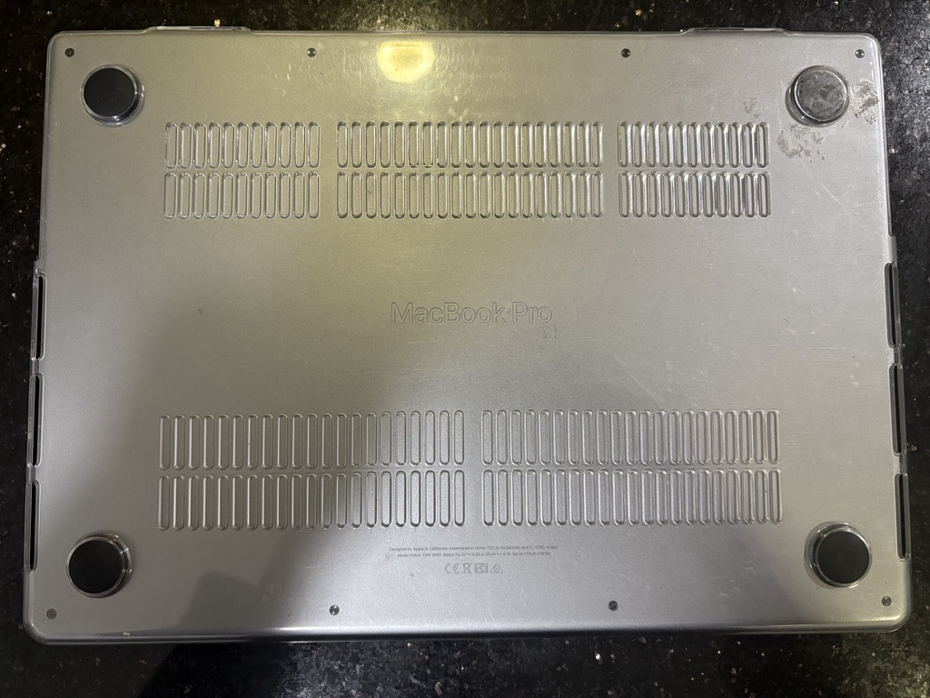

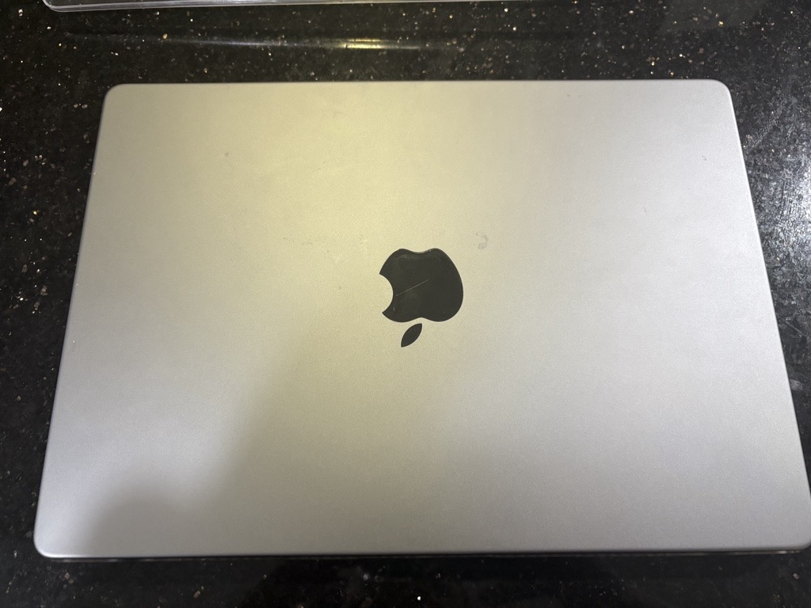

How to Bid:
- Please send your bids to country.vietnam.general@asiafoundation.org before 4pm – Jan 10, 2025.
- Include the item(s) you are interested in and your bid amount.
- Bids will be reviewed, and the highest bidders will be contacted.
- The winner will be informed by email or via telephone after close bid opening. Please note that the winner will be responsible for all moving and uninstallation costs.

Contact: For more information or to place a bid, please reach out to 024 39433263 or country.vietnam.general@asiafoundation.org

